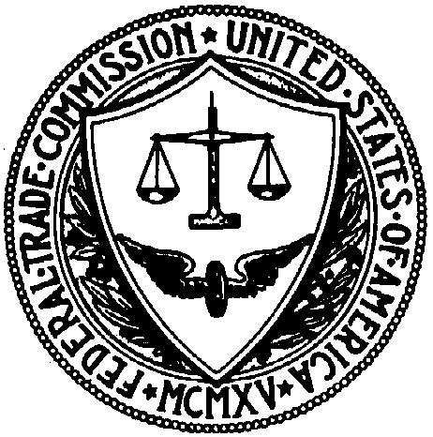
UNITED STATES OF AMERICA
FEDERAL TRADE COMMISSION
WASHINGTON, D.C. 20580

Bureau of Competition

Publicly Available Information
Concerning the FTC, DOJ, Antitrust Law & Health Care

1. FTC and DOJ Guidelines Affecting Health Care

a. Federal Trade Commission and Department of Justice Statements of Antitrust Enforcement Policy in Health Care, August 18, 1996.
Available at: www.ftc.gov/reports/hlth3s.htm

b. Antitrust Guidelines for Collaborations Among Competitors, issued by the Federal Trade Commission and the U.S. Department of Justice, April 2000. Available at: www.ftc.gov/bc/guidelin.htm

c. Horizontal Merger Guidelines of the Department of Justice and Federal Trade Commission, issued April 2, 1992, revised April 8, 1997.
Available at: www.ftc.gov/bc/guidelin.htm

d. Antitrust Guidelines for the Licensing of Intellectual Property, issued by the U.S. Department of Justice and the Federal Trade Commission, April 6, 1995. Available at: www.ftc.gov/bc/guidelin.htm

e. “Promoting Competition, Protecting Consumers: A Plain English Guide to Antitrust Laws.”
Available at: www.ftc.gov/bc/compguide/index.htm

2. Other Materials Concerning FTC Actions in Health Care

a. FTC Antitrust Actions in Health Care Services and Products -- summarizes all FTC enforcement actions, Commission advisory opinions, and amicus briefs in the health-care industry.
Available at: www.ftc.gov/bc/atahcsvs.htm

b. Commission Actions -- full text of complaints and consent orders issued by the Commission since July 1996.
Available at: www.ftc.gov/bc/CommissionActions/index.htm

c. Topic and Yearly Indices of Health Care Antitrust Advisory Opinions by Commission and Staff -- summarizes all Commission and FTC staff advisory opinions in the health-care industry.
Available at: www.ftc.gov/bc/adops/indices.htm

d. Advisory Opinions -- full text of advisory opinions in the health-care industry issued by the Commission and FTC staff since 1993.
Available at: www.ftc.gov/bc/advisory.htm

e. Staff Letters to Other Governmental Bodies -- letters to federal and state governmental bodies in response to requests for guidance on various aspects of competition policy in the health-care industry.
Available at: www.ftc.gov/bc/hcpolicy.htm

f. Speeches -- speeches by Commission personnel concerning the health-care industry.
Available at: www.ftc.gov/bc/speeches.htm

g. FTC Workshop on Health Care and Competition Law & Policy -- lists all publicly available information about the FTC’s health-care workshop and planned hearings.
Available at: www.ftc.gov/ogc/healthcare/index.htm

3. Materials from the Department of Justice, Antitrust Division, Health Care Task Force Concerning Health Care

The following materials are available at: www.usdoj.gov/atr/public/health_care/
health_care.htm

a. Health Care Task Force: Recent Enforcement Actions -- summarizes some of the more recent actions brought by DOJ in the health-care industry.

b. Health Care Case Summaries -- summarizes all DOJ antitrust civil, criminal, and merger actions in the health-care industry since August 25, 1983.

c. Business Review Letters Summaries -- summarizes all DOJ business review letters in the health-care industry since 1993 issuance of the DOJ/FTC Health Care Antitrust Statements of Enforcement Policy.

As of October 24, 2002

