Risk Management and Measuring Productivity with POAS - Point of Action System -
Masanori Akiyama M.D.,Ph.D.
Center for eBusiness, Massachusetts Institute of Technology Sloan School of Management, Cambridge, MA, USA, Department of Medical Informatics, International Medical Center of Japan, Tokyo, Japan
Abstract— The concept of our system is not only to manage material flows, but also to provide an integrated management resource, a means of correcting errors in medical treatment, and applications to EBM through the data mining of medical records. Prior to the development of this system, electronic processing systems in hospitals did a poor job of accurately grasping medical practice and medical material flows. With POAS (Point of Act System), hospital managers can solve the so-called, “man, money, material, and information” issues inherent in the costs of healthcare. The POAS system synchronizes with each department system, from finance and accounting, to pharmacy, to imaging, and allows information exchange. We can manage Man (Business Process), Material (Medical Materials and Medicine), Money (Expenditure for purchase and Receipt), and Information (Medical Records) completely by this system. Our analysis has shown that this system has a remarkable investment effect – saving over four million dollars per year – through cost savings in logistics and business process efficiencies. In addition, the quality of care has been improved dramatically while error rates have been reduced – nearly to zero in some cases.
Index Terms— POAS (point of act system), hospital management, ERP (enterprise resource Planning), financial management, CORBA (Common Object Request Broker Architecture

1 Introduction
There has been a tendency in medical care to give low priority to management processes and the improvement of efficiency; medicine has been regarded as a sacred area exempt from such changes. However, in September 2001 the Japanese Ministry of Health, Labor and Welfare made public a draft plan of medical system reform because of the need to seriously review the country's medical services. This was brought about both by the harsh economic conditions existing after the collapse of the asset-inflated bubble economy in the early 1990s and the aging of society accompanied by declines in the birthrate. The plan, which not only visualizes reform of the medical insurance system but also pictures an ideal system of medical care for the future, is a comprehensive draft for institutional reform in Japan. In concrete terms, the plan calls on medical professionals to respect their patients' points of view and allow patients to take responsibility for decisions regarding their own care; to improve the environment within which information is supplied; to provide high-quality, efficient medical care; to improve the quality of medical service and regional medical care security; and to introduce the use of information systems in providing medical services. The point of these suggestions is to foster respect for the options chosen by patients, to provide the information necessary for informed decision making, to establish a system that provides high quality, efficient medical service and to build a foundation for public confidence. Because of these proposals, economic efficiency in medical care is becoming an important public issue. In this context, information technology (IT) can serve as a helpful tool. When the improvement of efficiency is stressed, the quality of medical care may tend to be sacrificed. We have developed a system that, utilizing IT, can accurately calculate costs in a bid to maintaining a balance between efficiency and quality. At the same time, the system can also be used as a yardstick for the measurement and improvement of efficiency.
————————————————
Masanori Akiyama M.D., Ph.D is with Center for eBusiness, Massachusetts Institute of Technology Sloan School of Management and the department of Medical Informatics / Internal Medicine, International Medical Center of Japan. E-mail:poas@mit.edu, makiyama-kkr@umin.ac.jp

2 Materials and Methods

2.1 Points that need to be addressed
The traditional hospital information system (HIS), built by connecting order entries and the medical clerical system, takes in information about orders and outputs medical payment requests via a medical accounting system, which is actually a payment system. However, this kind of system has the following problems:
• Although physicians are supposed to enter correct payment information, the information is often incomplete (occurrence of uncollected balance).
• The data terminals within divisions and those at the HIS are not integrated. As a result, duplicate entries are required, resulting in unnecessary extra work.
• While data held in the HIS can be sent to the medical financial system, divisional data necessary for payment cannot be entered due to inconsistencies in the master system.
• It is difficult or impossible to search the information held by the medical financial or divisional systems via the order systems.
• A most important problem is that the existing systems have been used primarily for preparing medical payment requests. As a result, data on clinical activities, which have nothing to do with medical insurance, are not received (and could not be handled anyway) by the existing systems.
In these circumstances, when certain expenses are not covered by medical insurance, it has not been possible to make accurate assessments of expenses for materials and personnel through cost calculations based on the data held in the medical financial systems.

2.2 Outline of the system
To deal with these problems, we have designed a three-tier model [1]. The middle-tier application server is located at the center. We use a Common Object Request Broker Architecture (CORBA) on this application server. A standardized middleware server links all the components of each system to one another. The role of the application server is to mediate among the components of the various systems. Data and the events generated by medical activities, which take place in different components of the various systems, are sent to the application server. The original data itself is not transmitted; rather it is registered for management purposes in a repository. Queries for system data are made to the application server, not to the server of each division. The application server then collects the required data from the appropriate divisions, and sends it to the client that requested it. Using this “wrapping” technology one can connect specialized legacy-based systems which are customized for each corporation or hospital. The International Medical Center of Japan has integrated it’s existing medical financial systems by routing them through the application server and the CORBA middleware [2].
With the use of three new functions, the collection of data, secondary use of data and improvement of the precision of data has become possible. First, the Clinical Data Repository (CDR) is a large-capacity database that manages problem-oriented data structures and houses all clinical data so that clinical records can be accessed. Data not housed in any other component will be maintained in the CDR. All system data is stored in the CDR in order to guarantee that all data can be accessed from the clinical front line. Secondly, the Act Management System (AMS) has made it possible to support decision-making and manage work on a knowledge basis. The result is that the guidelines and protocols of clinical studies can be executed and managed. The AMS also records all changes in the condition of data, and all accesses to clinical data. This feature can be utilized to discover patterns of use by improving guidelines or recording diagnostic processes by analyzing detailed access logs for the systems. Thirdly, the Resource Management System (RMS) manages all the system resources that are normally available to a corporation. It can keep track of people and organizations – actors – connected to each system, fixed assets and equipment, and such resources as pharmaceuticals, film stock, contrast media and meals. Information obtained from the AMS can be invaluable when used for accurate and efficient distribution of resources.
Each divisional system manages data that has resulted from that division and its clinical work processes. Each division manages and preserves detailed data, including its reports, and provides only the “outlines” of the data to the application server. Thus, the actual data are not sent to or preserved in the application server. Since only outlines of data are held in the central application server, the volume of data stored there will not increase dramatically. Each client communicates with the others via the application server, and a graphic user interface (GUI) is provided for each occupational category.

Technologies used for the system
The system was built using state-of-the-art technologies such as CORBA and Java [4]. CORBA is used in the mechanism for data transfer and event distribution. We made a standardized interface using an Interface Definition Language (IDL), which was established by an object management group (OMG) to secure portability, extensibility and scalability of the components in the system. The GUI clients are implemented in Java. We used Extensible Markup Language (XML) to record variable length data. Document data is exchanged between clients and the application server. Meanwhile, CORBA Objects are exchanged between the application server and other components. The application server assembles and resolves XML documents obtained from sources in various divisions.

Implementation
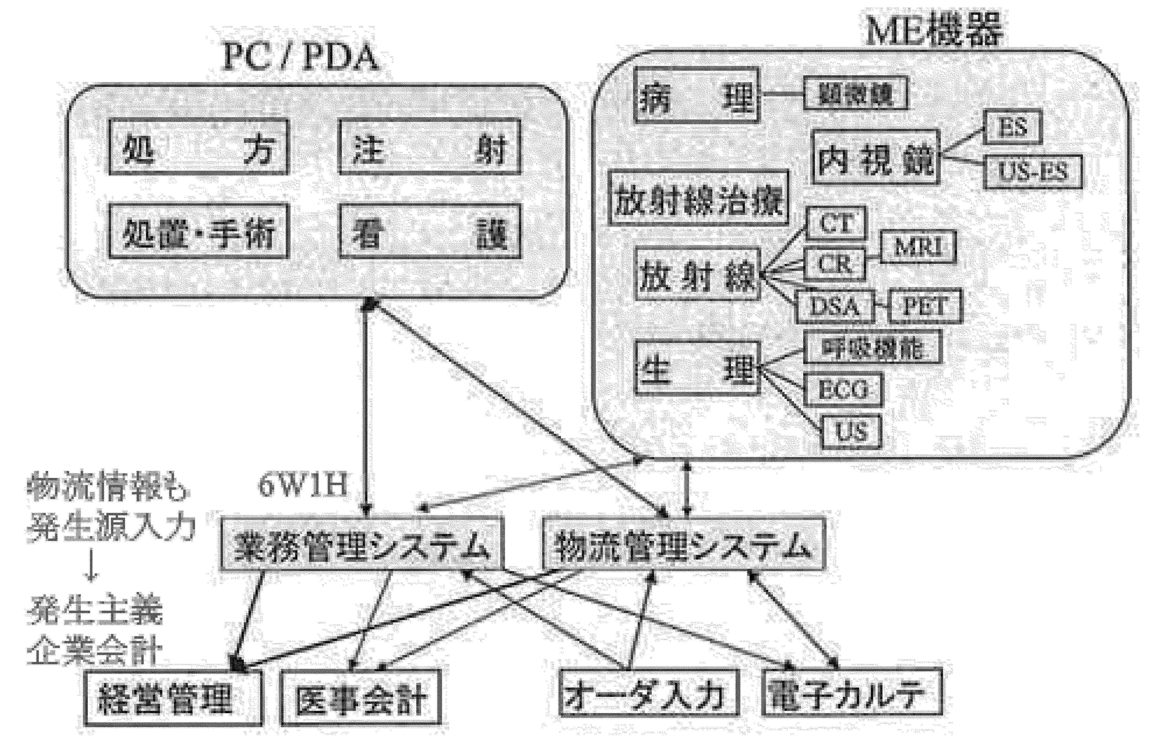
Using CORBA, an application server is implemented as an integrating system to link the servers in the endoscope division, the pathology division and the wrapped, legacy-based medical accounting system. It is possible to search and browse using the database on local area network (LAN) terminals. Orders, images, reports and the medical financial system are all integrated (Fig.1).

Prescription

Procedure,
surgery

Injection

Health care MIE
Equipment

MIE Equipment

Pathology

Radiation
therapy

Microscope

Radiation

Physiology

Operations control
system

PDA system

Management

Billing
account

Order entry

Electronic
chart

Act information is
entered on PDA

Activity based
accounting

Endoscope

Respiratory function

Fig.1 Outline of ERP system of IMCJ

Calculating medical care costs
Calculating medical care costs, which had posed difficulties that needed to be resolved, has now become possible. POAS, which stands for the Point of Act System, is a design feature of this comprehensive medical information system. Its characteristics are as follows.
1. Information on all medical activities is collected as detailed data at major “action” points, from the time orders are issued on through to their implementation.
2. The system is organically linked to various medical devices, such as medical diagnostic instruments, X-Ray equipment and equipment in the pharmaceutical division. It records information about medical activities, and their results, in a general-purpose database in various forms such as images, numerical values and text.
3. It uses a general-purpose data description method (AML) that enables flexible incorporation in response to advances in IT technologies.
4. It has a data warehouse structure, which collects and permits the analysis of detailed data at the level of individual medical activities.
5. It helps prevent medical errors – including mistakes at the stage of implementation – by making it possible to cross-check such data as patient identification, ongoing medical activities, medicines to be used and what personnel carry out the medical activities, each time an activity is executed.
6. It can be used to calculate profits and costs, based on orders. It will total them by medical fees, sectors or patients. These figures can be utilized as management in-formation.

Mechanisms for data collection
Data on medical activities at the points of action listed below can be collected centrally by direct connections to the order systems and the medical equipment in each division.
Order is input, received, changed or cancelled, implemented (contact is made with the accounting section), and completed.

Structure of order items
Necessary units of data recorded by the system, based on the idea of 6Ws and 2Hs , are as follows: Who-
the implementer (the person who placed an order, or the person who carried it out); to Whom - the patient; How - medical activities and changes in them; What - materials used (pharmaceuticals, medical materials and others); How Much - amount of materials used and the number of applications; For What - name of the disease subject to these medical activities; When - date when the order was placed, when it was implemented, and when it was discontinued; and Where - place of implementation (department, hospital ward, and equipment used). We have made it possible to calculate the costs related to each type of disease by entering the name of the disease along with each order.

3 Results

3.1 Operational track records
The underlying concept of this system is POAS, which enables records of “who did what to whom, where, when, using what, and for what reason” [5]. In short, real-time input becomes possible at the point of action. Logs, including inventories, are created. It becomes possible to reduce to a minimum the difference between expenses from medical activities and the amount claimed as lost by adopting the “accrued basis of corporate accounting” concept. In short, the management of divisions and their work, using a corporate financial/accounting system, has become possible by identifying the divisions that are incurring losses. The system operates continuously at the International Medical Center of Japan, handling 100 transactions per second, or more than 360,000 transactions per hour. It has been in continuous operation for four years.

3.2 Linking the hospital information system (POAS) with the management information system
The hospital information system concerning diagnosis and treatment (POAS) and the management information system, centered on accounting, are separate systems. Data collected as described above are compiled at midnight each day in the clinical database and then sent to the management information system. It calculates all costs in the early morning, using batch processing. As a result, management information from the previous day is available by 6:00 a.m.

3.3 Positive management analysis
The use of POAS makes possible management analyses based on objective data. The following kinds of analyses can be performed.

3.3.1 Profit-and-loss calculations for medical treatment departments/divisions

a) The difference between the new system and traditional “division cost calculations”
Under the old method, the medical treatment division is regarded as the profit center and the central medical treatment division is seen as a supplementary division. The complete personnel expenses of the hospital are distributed across the medical divisions and the central medical treatment division according to the ratio of their payrolls. The hospital's overall expenses are apportioned to the medical treatment division and the central medical treatment division according to the ratio of personnel costs (primary distribution). Then the expenses of the central medical treatment division are distributed to the medical treatment departments in proportion to their medical treatment earnings (secondary distribution), including those from radiology and other examinations.
Under POAS, the expenses of the central medical treatment division are not distributed, but scored as false earnings, called “in-house earnings,” making the division a quasi-profit center. That is, the central medical treatment division posts appropriate earnings to the medical treat-mint departments for the medical activities they carried out, based on orders. (The medical treatment departments use a method of scoring their expenses as in-house expenses).
The earnings and expenses of the medical treatment departments and the central medical treatment division are calculated on the basis of individual orders.

b) Effects
Costs are made clear not only in the medical treatment departments, but also in the central medical treatment division. By comparing earnings with expenses – a since profits and losses can be calculated – management can also check the appropriateness of these costs.
Defining the expense structures of money-losing divisions reveals divisions and expenses that should be subject to cost reduction.
The extent that an effort for improvement should be made is clarified by revealing the size of a unit’s losses.
It becomes possible to assess the results of management efforts in the medical treatment departments and the central medical treatment division by comparing their track records in a time series analysis.
Using the profit-and-loss calculation of the central medical treatment division, the efficiency of that division can be judged through a comparison of earnings with expenses.
It should become possible in the future to establish an annual program to set profit-and-loss targets for each medical treatment department and division.
Forms for the profit-and-loss statements issued by the medical treatment departments and divisions are automatically generated by POAS.

3.3.2 Profit-and-loss calculation by patient category

a) Characteristics
Earnings and expenses by patient category are calculated on the basis of orders.
After the shift to a fixed-fee system, costs should also be compared with earnings under the fixed-fee system, not on the basis of orders. This comparison will become the most important source of information for management judgments after the shift to a fixed-fee system.

b) Effects
It has become possible to judge the appropriateness of medical activities by comparing earnings and costs for individual hospitalizations.
For patients who are in an acute stage, or patients with catastrophic health insurance coverage, it becomes possible to review the appropriateness of medical activities based on profit and loss, when the amount of variable expenses and targets for improvement are defined. These expenses include pharmaceuticals, medical treatment, materials and examinations.
For patients in a chronic state, it is possible to review the number of hospitalization days and the amount of fixed expenses, including hospital ward expenses.
Again, the forms for profit-and-loss statements by patient category are automatically generated by POAS.

3.3.3 Calculating cost by disease

a) Characteristics
Using the disease group codes, input for each order datum can total cost by disease.
It is possible to identify patients who belong to a specific disease group and total their costs.

b) Effects
Now that it has become possible to develop statistics on the cost structure of specific disease groups, such statistics have become information sources when the levels of fees under a fixed-fee system are decided. (However, cost structures at other hospitals should be verified when the fee levels are determined, since cost structures differ from hospital to hospital.)

3.3.4 Profit-and-loss calculation by physician
Profit-and-loss can also be calculated for each attending physician or each physician who places an order (the physician in charge). The results of this calculation are referred to when the trends of the medical activities of each physician is assessed, based on detailed medical treatment data. However, it is dangerous to appraise physicians only on a profit-and-loss basis, since not only financial management factors are necessary, but also medical analyses are required for the qualitative appraisal of medical care.

3.4 Risk management

a) Characteristics
The difference between POAS and conventional systems is that POAS is not based on orders but on actions. Essentially, traditional systems were expanded versions of the medical accounting systems that were brought into nurse stations and outpatient departments. This means they were only capable of processing orders by day. As a result, these systems can cause time lags of anywhere between 10 minutes and up to several hours, posing a major problem for the medical workplace. To shorten the time-lag to meet the requirements of medical workers at the patient’s bedside -about 2 to 3 seconds- data granularity must be based on single vials. It is important to recognize at the outset that the Medical Affairs Section and the sections responsible for executing actual medical actions require different data granularities. If a system’s granularity were to be based on single items to begin with, its data could be easily compiled to derive the data required by the Medical Affairs Section as well. This is the reason why conventional systems have not been useful for improving productivity, gathering clinical data or improving management efficiency. While manufacturers conduct production control on their drugs and medical supplies by single types, by the time these products reach the hospital through the wholesaler, they are batched together into units of boxes or purchase orders. As a result, conventional material flow systems process these items by the shipping slip and not by single types. Even if these products were checked by shipping slip or per day, once an accident occurs, it would be too late to prepare electronic medical charts. To prevent accidents, these products must be controlled as single items from the outset. When the shipment is received, POAS controls these items as single types, not by shipping slips. This helps prevent accidents since it allows hospital operators to implement the same level of quality control as the manufacturers.

b) Effects
According to a survey of injection prescriptions previously conducted at the International Medical Center, changes were ordered for 20% of these prescriptions at one time or another. Since then, the average hospital stay has been halved to 15 days, and we used POAS to calculate the rate of injection instruction changes for a one-year period ending October 2004. Changes were ordered for 24% of the “injection prescriptions” between the time they were issued and the “injection mixing” step. In addition, changes were ordered for 15% of the instructions after “injection mixing” (Fig.2). This shows that changes were ordered for a total of about 40% of the instructions. These changes should have doubled the amount of work for nurses and pharmacists, but their actual workloads did not increase. There was a reduction in nurse overtime and the number of accidents fell to zero. Similar improvements were seen at the Morioka Red Cross Hospital after they began using POAS. This was because automation eliminated tasks such as filling out and transferring slips, which previously took up most of the nurses’ time.
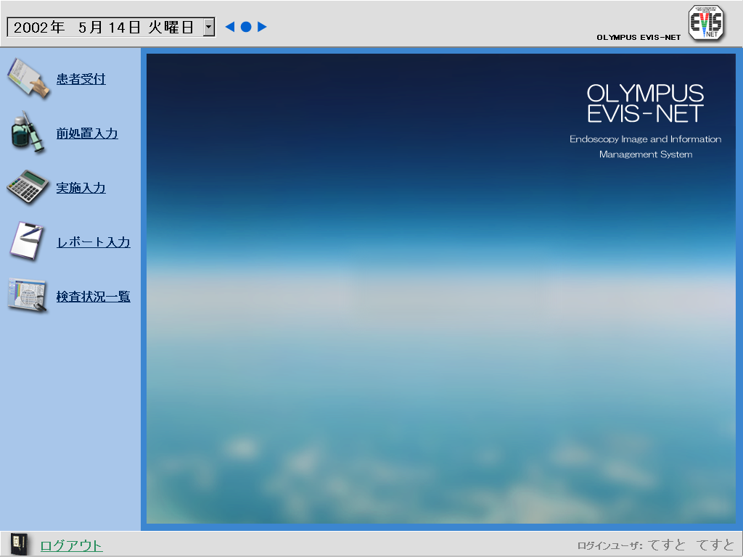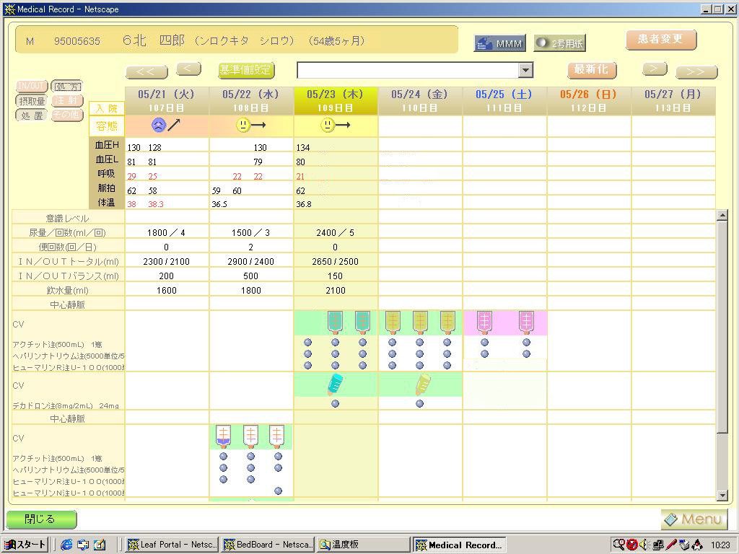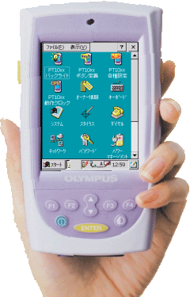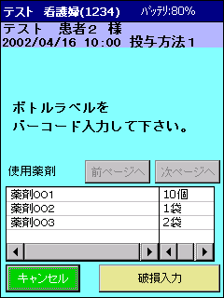

Ward / Outpatient (HIS)

750 orders/day
2,329 drugs/day
IV drip bottle
Neither cancellations
nor changes
570 orders/day
No change to route speed
454 orders/day
(802 Rb/day)
Nurse station
(HIS)

570 orders/day
(1006 Rp/day)
1,770 drugs/day
Bedside
(Mobile terminal)

1006 Rp/day
Issue injection prescription
Perform
mixed injection
Action entry
Canceled or changed orders
180 orders/day
(318Rp/day)
About 37 thousand/month

Changes made to route speed
116 orders/day
(204 Rb/day)
There is a possibility of misadministration of about 40% if the change of order is not communicated in real-time.

２４％

１５％

Fig.2 The effects of making injection action entries (calculated from performance data)

This table shows a map of nurses’ actions from midnight to midnight. POAS also records nursing and care procedures. The logged records are 400 thousands / month, then about 80 million logs and 18 million records accumulated over two years. We can see that a variety of workloads are concentrated in the 9:00 AM to noon timeframe. This is because the morning shift starts at 8:30 for types of work. Most of the important medical actions are carried out before noon and 40% of the prescription instruction changes also procedures during this time. This is a hazard-prone timeframe that produces the most accidents and incurs the most wasted. 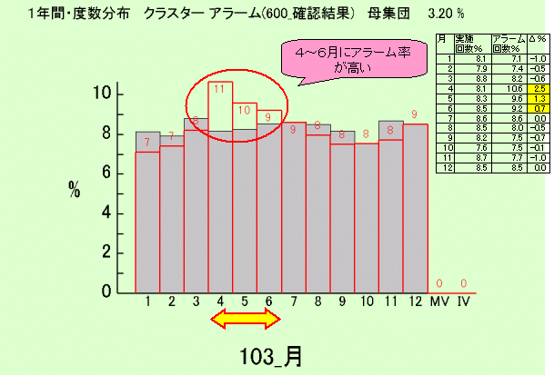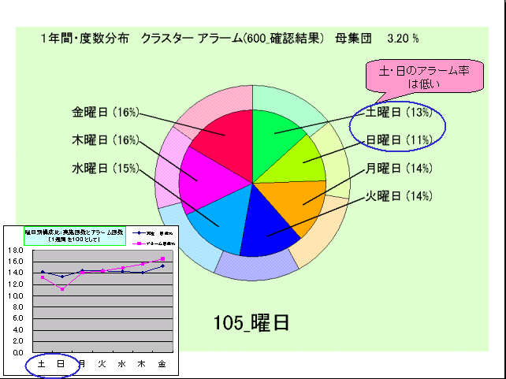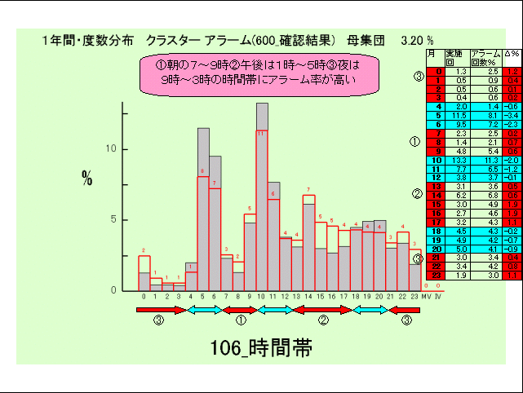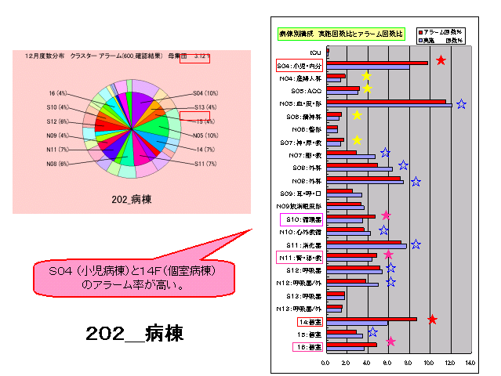
Fig.3 Basic analysis: From the frequency distribution of variables
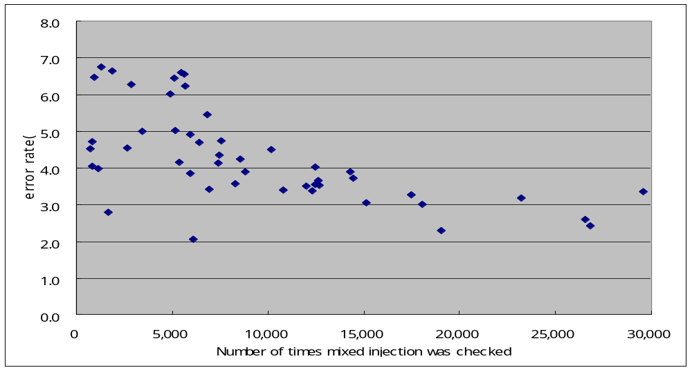
The number of check actions and the error rate have a slightly negative correlation.
Coefficient of correlation ＝－0.6
The smaller the number of injections a nurse performs that day, the higher the alarm rate.
Fig.4 Comparison of the number of times mixed injections were checked and error rate (%)
(by different time segments)
The grayed area (upper left) of this graph shows the nurses’ total workload. The bar graph with the red frame shows the frequency at which a nurse triggered an alarm and is scaled to proportion. There were a large number of alarms in April, May and June. Obviously, none of these resulted in accidents since alarms were triggered. Since the workload is constant throughout the year, this increase is likely to be due to new nurses joining the workforce in April (Fig.3).
Injection accidents are most likely to result in personal injury. Therefore, here we analyze the causes of injection alarms. The horizontal axis shows the total number of injections performed and the vertical axis shows the alarm rates (Fig.4). Each point corresponds to a single sample with a duration of 30 minutes each. The values are for the entire hospital for a period of one year. It shows that alarm rates were lower during time segments in which a large number of injections were performed and were higher during time segments in which fewer injections were performed. This indicates that accidents do not necessarily occur because nurses are busy.
Fig.5 shows the number of errors and error rates in 30-minute increments. You can see that the alarm rate increases immediately after a shift change. Additionally, you can see that the execution of instructions that were specified for 6:00 a.m. were scattered over several hours between 4:30 and 7:30. Conventional electronic medical chart systems will show these as being administered at 6:00 a.m. and there will be no way of getting a picture of the actual situation. With the POAS system, users can not only track this information, but also analyze the effectiveness with pharmoco-kinetics and blood kinetics, as well as efficacy for different administration times. The height of the curve becomes progressively lower for the second, third and fourth injections, and the dispersion becomes more evident. This is likely due to the fact that the first injection is started at around 6:00 a.m. and the second and later injections are IV replacements performed in response to nurse calls. The important point here is that the timeframe before 10:00 a.m. is potentially extremely hazardous. This is the timeframe during which powerful drugs are used the most often, with a corresponding spike in the number of incident and accident reports.

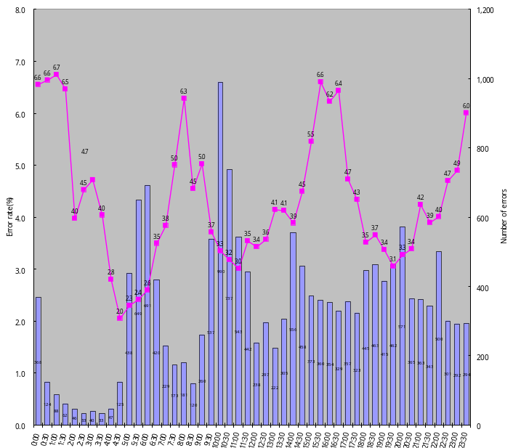
Time segments with higher alarm rates become even clearer when seen in 30-minute increments.
Fig.5 Alarm status by different time segments
The reason for this is because this is when second IV drips are usually given. Drugs with strong side-effects are given in the second IV drip after the patient’s body has been re-hydrated with the first.
These were divided into three: before, during and after nurse hand-over (Fig.6). Each of these was then categorized into day, evening-night and late night shifts for a total of 9 zones, to examine the time segments with high alarm rates. In every case, nurses who have been on their shifts for 6 or more hours tended to trigger more alarms. You can see their concentration levels dropping during the last 2 hours in an 8-hour shift, making this a hazardous timeframe. We believe daily shift schedules based on three 8-hour shifts must be reconsidered. This interpretation, however, does not explain errors that occur “immediately after the beginning of a shift”, according to the left side of the upper-right graph.
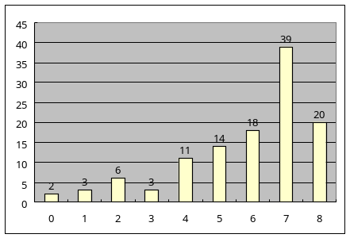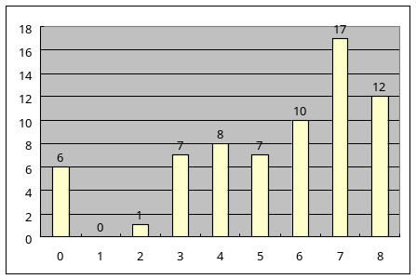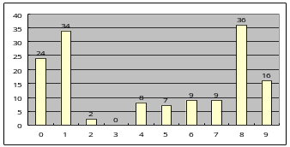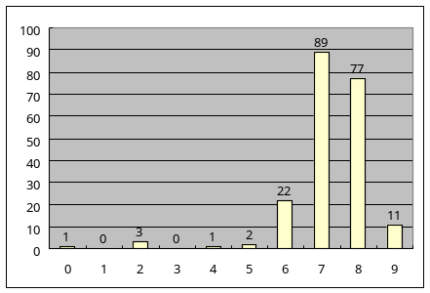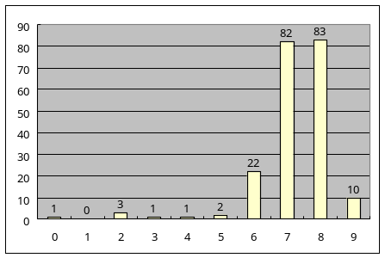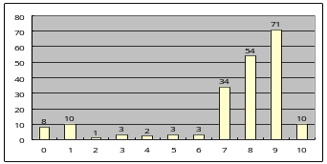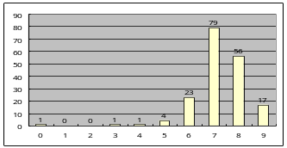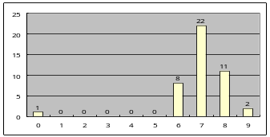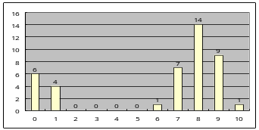
Hand-over time segment
8:30－9:00
16:30－17:00
0:30－1:00
Before hand-over time
8:00－8:30
16:00－16:30
0:00－0:30
After hand-over time
9:00－9:30
17:00－17:30
1:00－1:30
<Time elapsed on nurse duty that day (hr)>
Nurses right before the end of their shift
Nurses right before the end of their shift
Nurses right before the end of their shift
Day shift
Semi-night shift
Error rate
6.3％
Error rate
6.2％
Error rate
6.6％
Error rate
6.4％
Error rate
6.6％
Error rate
4.5％
Error rate
5.0％
Error rate
6.7％
Work status of nurses who trigger alarms around the hand-over time.
<Number of errors>
Nurses right
at the beginning
of their shift
Error rate
4.7％
Late night shift
Fig.6 Error rates for time elapsed on nurse duty (before and after hand-over time)

The alarm rate was the highest for IV injections performed at around 10:00 a.m., immediately after the beginning of the day shift. These are usually the first IV drips that a nurse or physician performs and include, for example, IV drips that are performed immediately on the spot based on verbal instructions (verbal implementation) from a physician making his or her rounds(Fig.7). This is because this is the time when most prescription changes are made.
The timeframe around 10:00 a.m., when most instruction changes occur, is also the time when more drugs are stored under refrigeration than in any other timeframe (Fig.8). The late night shift nurse usually prepares the drugs to be mixed on a table before the end of his or her shift, and leaves a note regarding refrigerated drugs, as these cannot be removed from refrigeration. The nurse who takes over must mix the drugs and replace the IV drip in response to a nurse call, but can sometimes forget to mix the refrigerated drug. Conventional systems will not trigger an alarm if the nurse forgets to mix the refrigerated drug. This is because these systems are not capable of detecting a lack of drugs. POAS will sound an alarm if there is a drug lacking yet to be mixed. Thanks to this system, the International Medical Center was able to reduce its injection accidents to zero.

Individual differences were found among those who triggered alarms. The alarm rates for the nearly 200 physicians who actually performed injections and 97% of the 600 nurses were less than the medians of 3% and 6%, respectively (Fig.9). However, slightly over 2% of the nurses had alarm rates of up to 12%. These were the so-called “repeaters”. The problem may be that they were working under unreasonable shift schedules or there may have been a problem with their training programs. With POAS, hospitals can identify potentially hazardous elements and take appropriate measures before a disaster occurs.

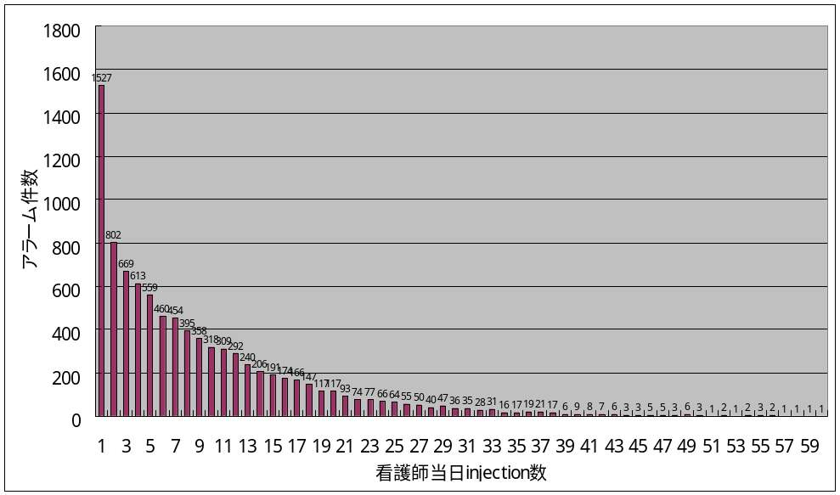
Study regarding the phenomenon where the alarm is more likely to be triggered on the first injection or IV drip on a nurse’s shift.
Alarms on the first injection
= 1,527
Alarms on the second injection
= 802
The alarm rate for a nurse’s first injection of the day was unusually high.
There was a significant increase in the
alarm rates for first injections.
P=0.000000000000000000000082397(10⁻²³)
Number of injections performed by a nurse that day.
Fig.7 Study of alarm status of First injection/IV drip

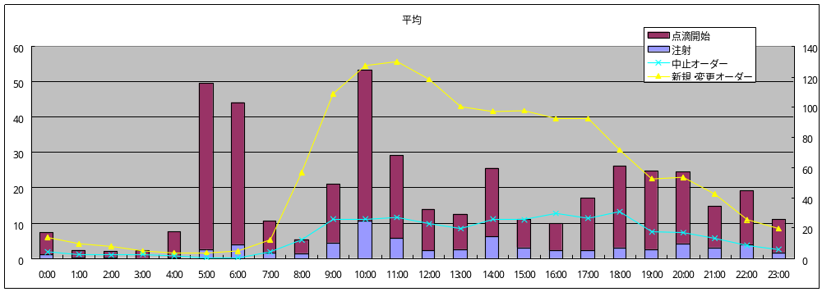
Fig.8 Time that injection and IV drips were started and order frequency

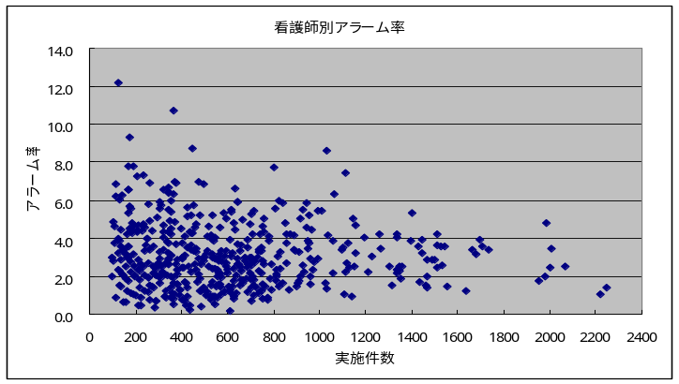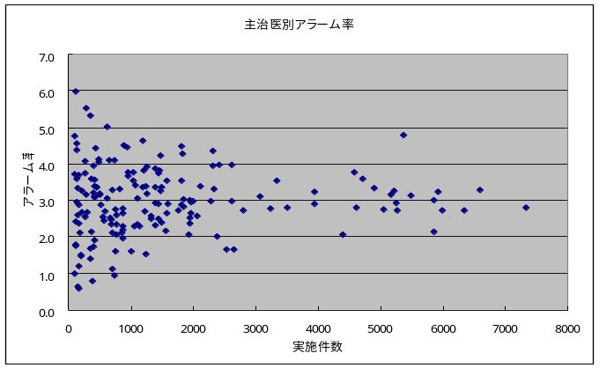
Nurses with relatively high
alarm rates
Physician in charge with relatively high alarm rates
Nurses mainly
serving Ward A
(年間100件以上実施者のみ)
Distribution of alarm rates for number of actions taken by nurses
There were certain nurses with relatively higher alarm rates.
同じく主治医毎の実施件数に対してのアラーム率の散布図です。
Number of actions taken
Number of actions taken
Alarm rates by nurse
Alarm rate
Alarm rates by physician in charge
Alarm rate
Fig.9 Unusually high alarm rates among certain nurses or physicians

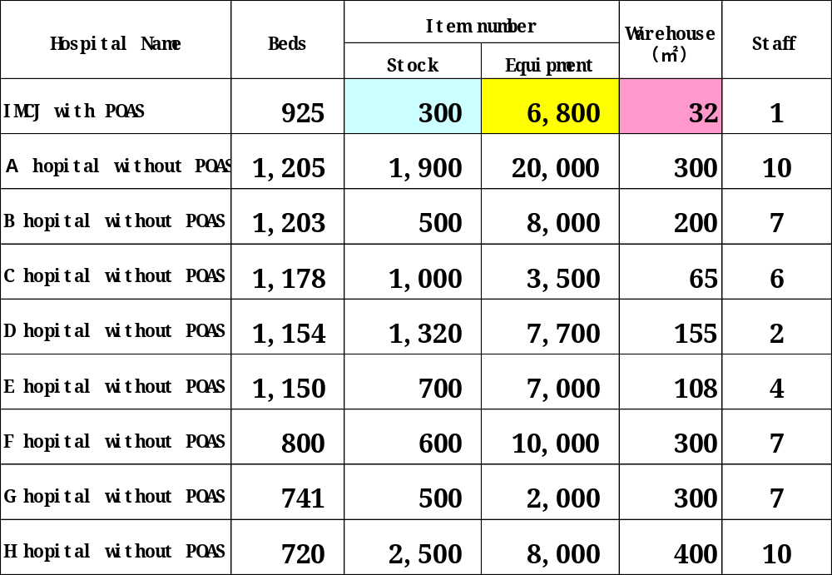

Fig.10 POAS’s characteristics

Inventory was cut to a tenth.
A cost reduction of 225.5 million yen was achieved for pharmaceuticals and 241.62 million yen for medical supplies.

3.5 Inventory control

a) Characteristics
The system has an inventory management user interface, but has no entry user interface. This is because a barcode scan substitutes for an inventory entry. The staff will not see their inventory increase either. Inventory is always maintained at a constant level because the system automatically makes arrangements for replenishments the moment a barcode is scanned when a drug or medical supply is used. Injection returns are also processed by barcode scanning. As a result of our efforts to achieve improved risk management, POAS-based hospital management systems are able to achieve “real-time entry and single item management,” which is critical, but they also offer the added benefit of reducing inventory. This is why the system is capable of responding to data regarding cancellation and changes. You can determine a system’s effectiveness just by verifying whether or not it can track single items of drugs and medical supplies.

b) Effects
Hospitals can also reduce inventory (Fig.10). With conventional systems, material flow was managed by an independent system, making it impossible to manage inventory accurately. With the POAS system, the database that manages injection orders and actions is the material flow database itself, and is capable of tracking individual drugs and medical supplies. This system was instrumental in cutting one client’s inventory to a tenth of their previous level. Inventory of drugs and medical supplies was reduced by a combined total of 450 million yen and the client was able to turn a profit after only one year.

4 Discussion
Conventional hospital information systems are typically linked to other divisional information systems through the order entry system vendor. However, such centralized systems do not necessarily conform to the actual state of affairs within which the front line of medical care functions, led by the separate divisions. Linkage between divisional systems has become easier, thanks to recent distributed object technologies that have made it possible to design an order entry system centering on the divisions [6, 7]. With this system, on-site units not only output images and medical payment requests, but also record “where and when who did what to whom, using what, and for what reason.” In short, it becomes possible to enter the sources of events which generate logs that are useful for healthcare management.
We have reduced the difference between the expenses involved in performing medical activities and the amount claimed for the activity (the loss) by adopting the idea of “an accrued basis for corporate accounting.” We have built a system that covers the management of divisions and medical work by using a corporate financial/accounting system that identifies which divisions incur losses.
As a result, it also becomes possible to assess each admission. Appraisal and review of clinical paths themselves is also made possible. We have found that there is no point in comparing the profits and losses of medical treatment departments and wards uniformly, since actual analyses of profit-and-loss indicated that each medical treatment department/ward has different characteristics. Therefore, we found it better to focus our efforts at improvement using comparisons of time series data from the same medical treatment department/ ward. Losses are inevitable at some medical treatment departments and wards for institutional and political reasons (e.g., they are treating multiple antibiotic-resistant tuberculosis). In this context, we concluded that money-losing divisions should be asked to make efforts to reduce their losses by setting goals, rather than to attempt to turn uniformly profitable.
This system not only aims to provide risk and logistics management, but also comprehensive oversight of management resources, means of preventing medical errors and the application of medical execution records to evidence based medicine (EBM). The system can also conform to a package payment system. Conventional systems could manage logistics in the central materials division, but it was difficult to manage materials accurately at the point of consumption in each division and department. The POAS system incorporates an online bar-code check via newly developed portable terminals. It firmly establishes an efficient business system that records the relationships between materials use and work – which had not previously been recognized – and it eliminates waste. Simply stated, POAS enables users to relate medical activities to materials accurately, even though they are not listed on medical payment requests, and to confirm the real-time movements of materials and patients, after eliminating duplicate inputs and reducing clinical labor. Material on data that accrues within each division’s system is transferred simultaneously to the management control system.
The systems in all divisions, including the one in the cost center, are linked with one another. For instance, the moment that the shutter of an endoscope is released in the medical treatment division, the points given under the medical insurance system are transmitted to the medical accounting department. At the same time, the images are preserved and the information is recorded, including the name of the person who took the pictures, how many images were taken, the equipment used and the length of time it took, and the type of examination. The system simultaneously outputs data for medical fee requests, data for management of the hospital, work and supplies, and data to support medical treatment, including the images and reports. In short, it enables users to have a complete picture of the movements of personnel (work), goods (medical materials, pharmaceuticals and others), money (purchasing expenses, expenses claimed, etc.) and information (medical records and so forth). It can also reduce labor on the front lines, as there is no need for slips for medical payment requests under the medical insurance system or medical accounting slips.
Conventional systems have failed because they were designed for medical administration processes. In Japan, order entry systems essentially consist of terminals connected to medical databases that were developed in the 1970s. In 1999, ordering systems connected all divisions of a hospital and paperless systems were almost complete. However, in and after 2001, the average hospital stay had to be shortened as medical regulations in Japan changed. Conventional systems were not able to respond to this new requirement. To shorten an average hospital stay, information on medical actions taken in the hospital room as well as in the emergency room needed to be digitized. These areas that have not been digitized were the most accident prone and incurred the most cost. In other words, conventional systems cannot reduce the medical accidents or costs. POAS is the only system that is capable of digitizing information on actions, and it requires completely new Internet-type technologies and configurations.
The injection user interface of POAS shows that the injection ampoules, vials and bottles are all given different numbers. Users can see the progress status of all of the ordered injections at a glance. The benefit of system integration is that hospital operators can automate medical invoices, cost calculations and inventory control simultaneously.
There are the problems of conventional medical chart systems using an injection order. For example. In conventional systems, when an “injection prescription” is issued, the prescription is sent to the “medical affairs” and “pharmacy” sections. To make changes to this prescription, the new information must be entered in the “Make changes to slip” screen. Since these are digitized versions of traditional slips and steps, the person must replace all of the data on the slip. Then, the instruction is confirmed when drug “audit” is pressed and all subsequent actions are checked against this instruction. This is because the system is incapable of handling units of information smaller than an injection prescription after an “audit.” Since there will still be some time until the bedside actions are to be performed, changes may be made to this instruction before the scheduled time. However, even if a physician ordered a change, a barcode scan would not trigger an alert. To avoid an accident, the instruction change must be accurately communicated to the ward. In contrast, POAS confirms data for each “action,” so every time a barcode is scanned, it also checks for any changes to the instruction. It also automatically records returns that result from instruction changes. In conventional systems, these returned items were left at the wards, unreturned and unchecked, resulting in a buildup of hidden inventory at the wards. Interest costs on inventory can be substantial since hospital inventory can amount to up to several hundreds of million yen. With the POAS system, the International Medical Center was able to cut its 600 million yen inventory to a fifth of what it was. Conventional systems will not give you the capability to improve your management efficiency from an inventory standpoint. In conventional systems, for example, if an injection instruction (order) includes prescriptions for three days, three slips will be issued, one each for the first, second and third days. This is because medical invoicing systems have a granularity of one day. Therefore, to make partial changes, this data must be completely replaced. In contrast, POAS assigns unique IDs to each drug to identify them. Additionally, each time any of these are handled, the person who took the action and the details of the action are recorded automatically in real-time. As a result, the system gathers a huge amount of data. By switching from a conventional system, the amount of data generated at the International Medical Center per unit duration increased by 100- to 1000-fold. Regular computers cannot function under such a load. While many venders have attempted to design similar client-server based systems with little success, POAS actually continues to deliver a quick performance.
Without the POAS technology, the system would have to control all the data in a massive centralized database. The POAS technology is similar to web2.0 technology. While such client-server based systems will slow down and become unusable in 3 to 4 years, the POAS system at the International Medical Center continues to provide quick performance. This is because the actual data resides on systems used at each division the POAS processes only their location data. Our technology enables the high-speed processing of data that multiplies 1000-fold.
In conventional systems, prescription changes made by a physician would take several minutes to several hours to be reflected on terminals used by nurses or the pharmacy. Hospitals have experienced accidents even when barcodes were scanned during a procedure because no alarm sounded at the time. In POAS, all the information including prescription changes made by the physician, as well as confirmation points for nurses and pharmacists are on a shared database, so the information is reflected in 2 to 3 seconds. This eliminates injection accidents. The displays also reflect the use of a shared database. While displays for physicians, nurses, pharmacists and co-medical staff all have a different appearance, any shared data content is queried from the same database. POAS uses a single set of data for controlling processes. This is because data duplication results in inconsistencies and accidents.
You can imagine that an accident occurs. Is the physician responsible for the accident? The relation between a sequence of processes is crucial for preventing accidents. It would be impossible to reproduce the situation in conventional systems, but POAS makes this possible. By analyzing the actions of the person in question as well as those of the people connected with this person, hospital operators can establish systems and organizations that are robust in terms of accident prevention.
POAS is also effective for financial management in hospital. Conventional electronic medical charts record only data required for medical administration as indicated in blue-purple as Fig.11. These systems can only track costs for purchases made by the hospital as a whole and cannot record the cost of material used at each department. Therefore, under existing cost calculation methods, the total cost of the material of the hospital is allocated to each department according to the revenue ratio of each department. POAS manages by each particular items of supplies, allowing hospitals to track the cost of supplies that are actually used in each department.
Fig.12 shows the revenue and expenditure of each department. The blue line shows revenue and expenditures using a revenue-proportionate method of allocation typically used by hospitals. The red line shows revenue and expenditures based on POAS’s cost calculation that reflects actual situations. We can see in this graph that some departments that were running a deficit are now turning a profit.
Let’s make an accurate cost calculation using POAS based on data generated in a hospital over the course of a year. Ninety percent of the patients treated by the group running the largest deficit were emergency patients (Fig.13). Groups that were making a profit treated very few emergency patients. This tells you that emergency treatments are unprofitable By dividing groups into money-losing and money-making groups, you realize that most of the patients treated by the group running the largest deficit were emergency patients. Obviously, this deficit should be offset with transfers from general accounts. While conventional systems will not be able to calculate amounts that should be given from public budget, hospitals using the POAS system can calculate the amount per division that should be authorized as expenses (since these divisions provide critical services to citizens) and present these expenses to make budget requests to the government.


C診療科
B診療科
A診療科
Department A
Department B

Department C

1 million yen
100 thousand yen
500 thousand yen
2 million yen
4 million yen
4 million yen
8 million yen
1.6 million yen
Materials
Allocation method
POAS
material costs actually used
Department’s material costs
＝
Revenues
400 thousand yen
800 thousand yen
800 thousand yen
1 million yen
100 thousand yen
500 thousand yen
Material costs (pharmaceuticals, medical supplies, etc.)
Directly charge actual amount used
Allocation by ratio of expenses to revenues
Department’s material costs
All material costs
×
department’s revenue
total revenue
＝
Department A
Department B
Department C
Fig.11 Cost calculation process (difference between the allocation method and POAS)

Conclusion
Since our focus was to develop a system based on data capture at the point of action throughout the hospital, this system is designed to be able to unitarily analyze data for better healthcare management. Our analysis has shown that the cost savings effect alone is over four million dollars per year. The quality of care and improved outcomes has shown equally significant improvement.

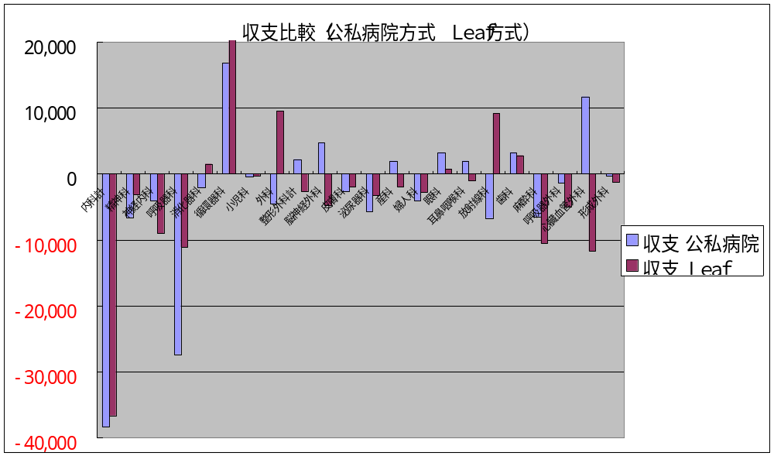
Misconstrued as being in the red when the books are actually in the black?
Actually
in the black
Actually
in the black

Profit
Deficit
Current allocation methods are not capable of making
accurate calculations of costs that would result in a deficit.
Actually
in the red
Revenue comparison (public and private hospital system, Leaf system)
■Revenue and expenditure
Public and private hospitals
■Revenue and expenditure
Leaf
Fig.12 Revenue comparison (public and private hospital system, Leaf system)

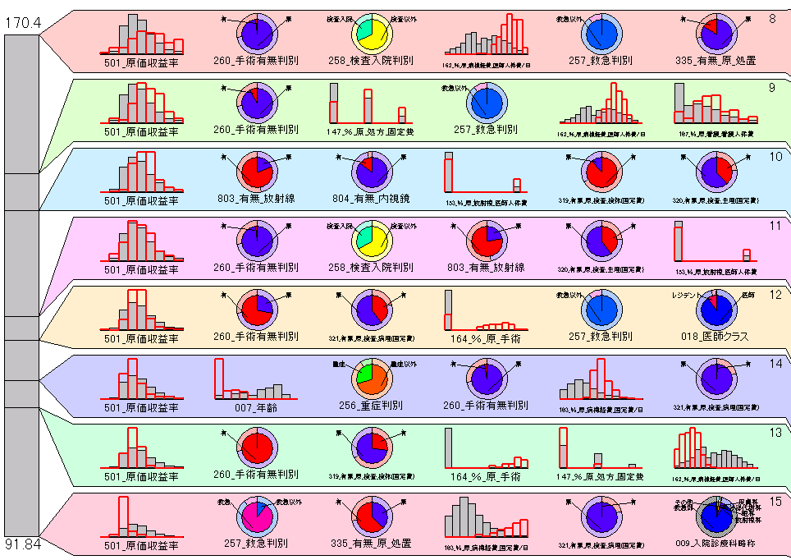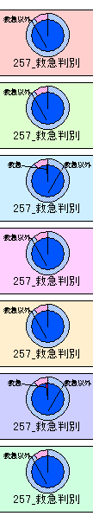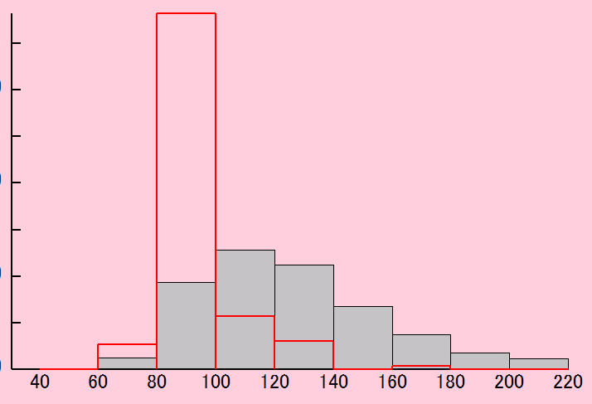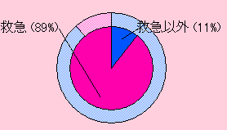
①
②
③
⑤
④
⑦
⑥
⑧
①
③
④
⑦
②
⑥
⑤
⑧
原価回収率平均：148.7
サイズ: 14.6%
原価回収率平均：142.9
サイズ: 14.4%
原価回収率平均：170.4
サイズ: 12.8%
原価回収率平均：122.7
サイズ: 10.5%
原価回収率平均：126.3
サイズ: 11.0%
原価回収率平均：112.1
サイズ: 14.3%
原価回収率平均：116.3
サイズ: 10.0%
First, the primary cause for Group (8)’s low rate of return on cost—100% or less (deficit)—was analyzed.
Emergency determination in other groups
①
③
④
⑥
②
⑦
⑤
救急
以外
救急
以外
救急
以外
救急
以外
救急
以外
救急
以外
救急
以外
原価回収率
Rate of return on cost
Average ：91.8%
The majority of causes in the case
of groups determined to be in the
red were related to emergencies.
Emergency determination
Emergency
Profit
Deficit
Average rate of return on cost ：91.8
Size : 12.4%
Fig.13 RBF analysis test

References
- Schmidt DC, Vinoski S. Object Interconnections, columns 1-14. http:// www.cs.wustl.edu/~schmidt/report-doc.html
- Akiyama M. Migration of the Japanese healthcare enterprise from a financial to integrated management: strategy and architecture, Medinfo. 2001: 10(Pt 1): 715-718.
- 7PKC Corporation. A Problem Oriented Approach to the Computerized Patient Record. 1998. http://www.pkc.com
- Bosak J, Sun Microsystems. XML, Java and the future of the Web. March 10,1997. http://sunsite.unc.edu/pub/suninfo/standards/xml/why/ xmlapps.html
- Akiyama M. Integration of Medical Information System as ERP (Enterprise Resource Planning) in Medical Field. Proceedings of the Forth China-Japan-Korea Joint Symposium on Medical Informatics. 2002: pp.56-59.
- Deibel SRA, Brigham and Womens Hospital. Component-based Computing: Perspectives from Healthcare. http://www.arachne.org/
- Burt CC, 2AB Corporation. Enterprise Architecture Whitepaper: Managed Migration to a Distributed Environment. http://www.2ab.com/ ea_wp.html
- Kaplan, Norton. The strategy-Focused Organization: How Balanced Scorecard Companies Thrive in the new Business Environment. Boston, MA: Harvard Business School Press, 2000.

Masanori Akiyama M.D., Ph.D
Department of Medical Informatics / Internal Medicine
International Medical Center of Japan. 1983 M.D. degree, School of Medicine, Faculty of Medicine, The University of Tokushima, Research Associate, Department of Urology, Schools of Medicine, Faculty of Medicine, The University of Tokushima. 1984 -Staff Physician, Department of Urology, Tokushima Municipal Hospital. 1988 -Research Associate, Department of Pathology, Schools of Medicine, Keio University. 1990 - Staff Physician, Department of Urology, National Shikoku Cancer Center. 1994 - Director, Medical Informatics, National Shikoku Cancer Center Hospital. 1997 - Director, Internal Medicine, International Medical Center of Japan. 1998 - Director, Medical Informatics, International Medical Center of Japan, and Assistant professor, Hamamatsu University School of Medicine, 1999 to 2002 Ministry of Health and Welfare, Japan health care bureau (Present: Ministry of Labor and Welfare healthy bureau) Department of National Hospitals policy medical treatment section. 2005 – present, Visiting Professor, Massachusetts Institute of Technology Sloan School of Management, Visiting professor, Tokyo Medical University, Assistant professor, Keio University School of Medicine, Assistant Professor, Hamamatsu University School of Medicine, Director of the Japan association for medical informatics.

